2027 St. Andrew’s T-shirt Logo Contest
The St. Andrew’s Society of Pittsburgh is holding a contest for the design of the 2027 Ligonier Highland Games T-shirt logo. This contest is open to all members in good standing, and the Executive Board will vote for the winning design.
Requirements
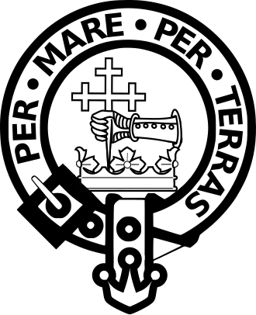
- The Clan Donald crest (pictured on the right) is to be incorporated into the design.
- The year of the games should also be incorporated into the design, not too well hidden. Next year’s Highland Games will be number 68.
- Up to three colors can be incorporated into the artwork.
- No copyrighted material is allowed to be used in the design.
- The winning logo will automatically become the property of the St. Andrew’s Society of Pittsburgh.
- The Board will select the color of the t-shirt fabric.
- Deadline for submission is August 31, 2026.
- Send designs to: John Hoffman, Jr., 121 Georgetown Ave., Pittsburgh, PA 15229, or email jchoffman12345@yahoo.com
What’s in it for you?
- A prize of two free 2027 T-shirts, plus your choice of one of the following:
  - Four tickets, with parking, to the 2027 Highland Games.
  - A bottle of your favorite Scotch valued at up to $150. (Proof of age is required.)
  - Two tickets to the 2027 Burns Supper.
  - A cardboard cut-out of you, for anyone who would want their picture taken with your image wearing the 2027 T-shirt. You get to take it home after we display it at the Highland Games and/or Tartan Day, whichever is last.
  - $150 Scottish Gourmet gift card.
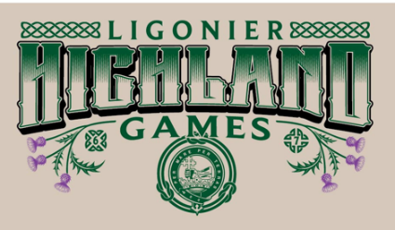
  - $150 Scotland Shop gift card.
Questions? Call John Hoffman at 412-627-4850.
2026
Design

