67th Ligonier Highland Games
2026 Souvenir T-Shirt Order Form
Pick shirts up at the Ligonier Highland Games July 18, 2026, or
select another shipping option below.
First Name |  | Last Name
Address
Address
City |  | State |  | Zip
Email |  | Phone
All shirts are $20 each.

Make Checks Payable to:
St. Andrew’s Society of Pittsburgh

Mail a check and this form to:
St. Andrew’s Society of Pittsburgh
c/o John Hoffman
121 Georgetown Avenue
Pittsburgh, PA 15229
NO PRE-ORDERS AFTER
June 15, 2026
Questions? Contact John Hoffman at: jchoffman12345@yahoo.com
Phone: (412)627-4850
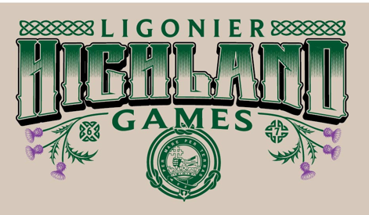
The design is on a tan T-shirt for men’s cut and peach for the lady’s cut.

Shipping Options
Shipping is a flat rate of $10 per order
☐ Check here if picking up at the Games on July 18th^{th}, at the St. Andrew’s tent on the field.
☐ Check here if shipping. (Add the fee on the left.)
Only paid orders will be processed.
Crew Neck: | Quantity
Small
Medium
Large
X- Large
2x-Large
3x-Large
4x-Large
V-Neck: | Quantity
Small
Medium
Large
x- Large
2x-Large
3x-Large
4x-Large
Total Quantity:
X $20
Shipping (Flat Rate)
$10.00
Total due:

