ST. ANDREW’S SOCIETY OF PITTSBURGH, INC.
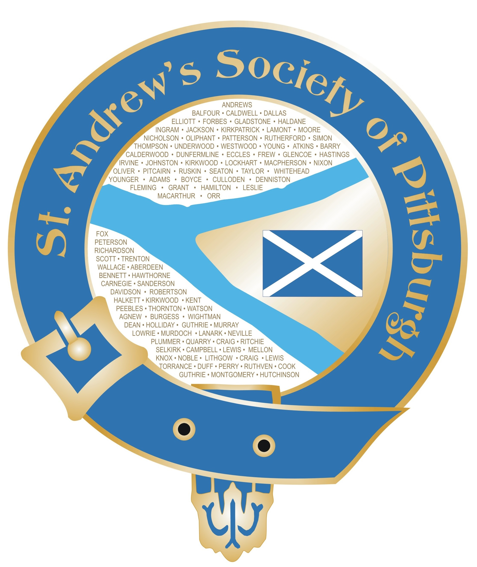
A non-profit 501(c) (3) organization
www.standrewspittsburgh.org

4530 William Penn Highway PMB 115
Murrysville, PA 15668-2000
Phone: 724-331-3265 Email: dalemcleod1@comcast.net

March 2017

The St. Andrew’s Society of Pittsburgh wishes to promote Scottish heritage and traditions by offering scholarships in the Scottish arts and traditions. They are awarded to people who are seriously studying, who have a need, and who demonstrate a willingness to develop and share Scottish heritage.

These scholarships are open to all people residing within the Greater Pittsburgh area who are actively practicing any Scottish traditions. Anyone wishing to be considered for scholarship money must complete the application form forwarded with this letter and return it as directed. A talented beginner will be considered equally with a more experienced student. Having received a scholarship in the past should not deter the applicant from applying again. It should be noted that financial assistance for costumes, supplies, and/or musical instruments will be considered along with workshop attendance.

It is hoped that good circulation of this application through schools, instructors, and other interested individuals will allow it to reach people who are interested and deserving of help in furthering their studies. Applications must be received by May 2, 2017. Members of the Scholarship Committee will review the applications and award scholarships based on the information received.

Feel free to pass this information along to others who may qualify. Make copies of the application as needed or download it from www.standrewspittsburgh.org. If you have any questions I can be reached at dalemcleod1@comcast.net.

Sincerely,

Dale McLeod
Scholarship Committee Chair
St. Andrew’s Society of Pittsburgh

