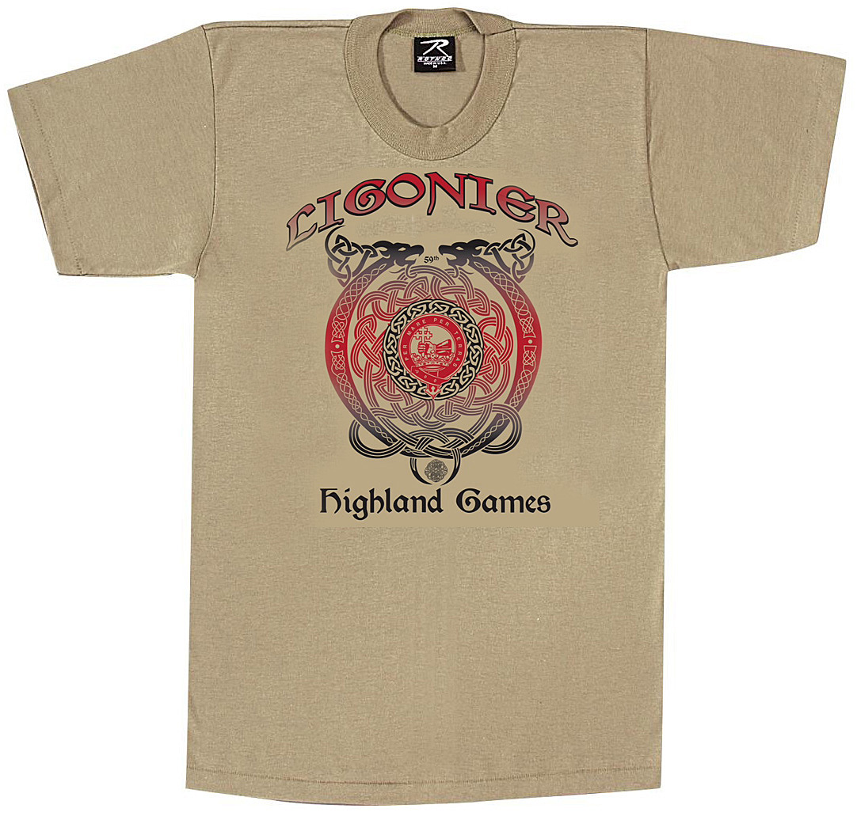

**2017 Ligonier Highland Games Souvenir T-Shirt**

Order Form

Pick shirts up at the St. Andrew’s Society Tent near the main field  
 September 23, 2017

First Name____________________ Last Name_________________________  
Address_________________________________________________________  
City____________________________________ State_____ Zip__________  
Email___________________________________ Phone_________________

SIZE  
Adult Small  
Adult Medium  
Adult Large  
Adult X-Large  
Adult 2XL  
Adult 3XL  
Adult 4XL

Subtotal

Flat Rate Shipping*  
 1 T-shirt  
Flat Rate Shipping*  
 2-6 T-shirts

PRICE  
$10  
$10  
$10  
$10  
$13  
$13  
$13

$6.95*  
  
$13.60*

QUANTITY

TOTAL

TOTAL DUE

Make Checks Payable to:  
 **St. Andrew’s Society of Pittsburgh**

**No Pre-orders after 9/13/2017**

*applicable if you want your T-shirt shipped

Mail to: Lyn Orr 117 Virginia Avenue  
 Aspinwall, PA 15215

**We will not hold shirts without payment!**

**Contacts:**   
Lyn Orr 412-782-2957 [lynreedorr@gmail.com](mailto:lynreedorr@gmail.com) Teresa 941-769-4162 thistle.pine@gmail.com